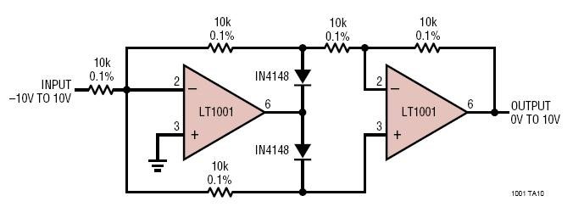
LT1001 Precision Absolute Value Circuit

The left op-amp is working in inverting mode.

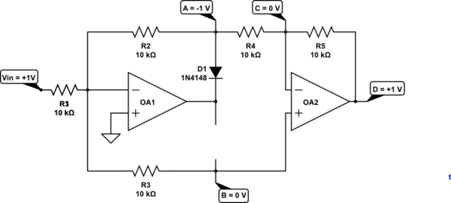Figure 1: Positive going input.

- If the INPUT voltage goes positive then the - input will start to rise above the + input and the output will start to go negative.
- D1 will then conduct pulling the - input back down to zero.
- The voltage on R2/R4 junction will be -Vin.
- The voltage on OA2 + input will be 0 V since it's tied to the virtual zero of OA1.
- OA2 is then operating in inverting mode so the output will be -(-Vin) = Vin.

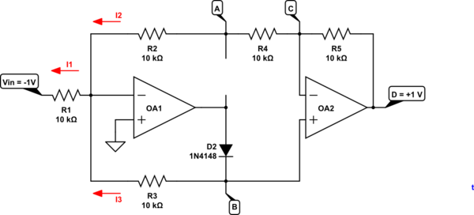Figure 2: Negative going input.

- When the INPUT voltage goes negative the cleverness of the circuit comes into play.
- OA1 - input will be virtual zero so I1 = 0.1 mA.
- If OA2 is in equilibrium both inputs will be at the same voltage. Therefore VB=VC
- Since there is 20k in the upper circuit and only 10k in the lower circuit .
- Therefore .
- OA2 is then operating in non-inverting mode so the output

